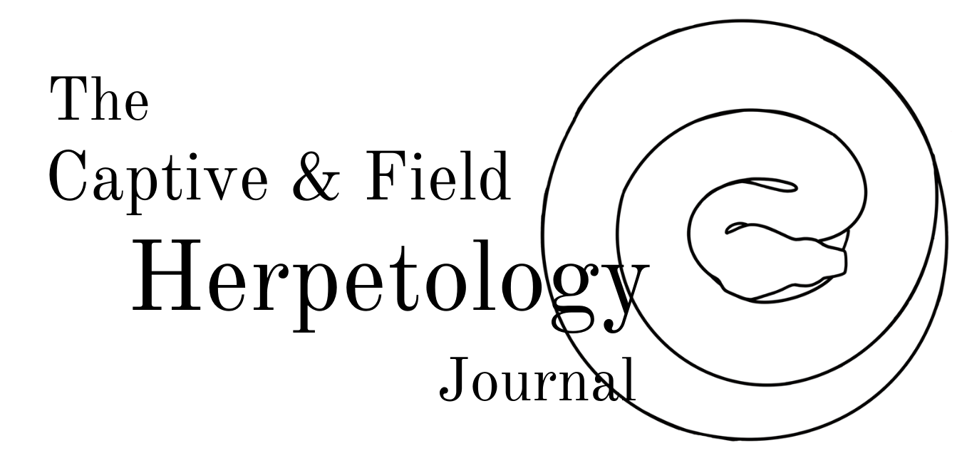
www.captiveandfieldherpetology.com

captiveandfieldherpetology@gmail.com
Title

Font ‘Times New Roman’ size 16
Bold
Author/s

Separate all names with ‘,’ and write in the format which you wish to use on the final manuscript

Font ‘Times New Roman’ size 14
Bold
Corresponding author’s email address

Font ‘Times New Roman’ size 11
Institutions/locations of authors

Write in the same order and corresponding with author’s names above

Font ‘Times New Roman’ size 11
Manuscript Type

Field report (natural history note, geographical based note, observational note or similar)

Captive report (observational note, breeding note, care note or similar involving captive animals)

Non-peer reviewed field report or similar

Book or literature review
Abstract

Paste abstract here if relevant, leave blank if no abstract

Font ‘Times New Roman’ size 12
Main Text

Paste main body of manuscript text here

Font ‘Times New Roman’ size 12
Reference List

Paste Reference list here

Font ‘Times New Roman’ size 12

Check submission guidelines for formatting
Word count
Date of submission
Do you confirm that this work is original, not published elsewhere or under consideration by another publisher?
Suggested Reviewer/s

Please list, along with contact details any person/s with the relevant experience and expertise to carry out peer review

Leave blank if no person/s are known

Note, this does not guarantee that the name/s mentioned above will be asked to review this manuscript. C&FH will deem the suitability of a reviewer/s.
Other Notes | - All submissions must be in English.  - All submissions must follow the format highlighted above and highlighted in the submission guidelines section of the website. Submissions which do not follow one or more of these will be instantly sent back to the author/s for edits to be carried out.  - See submission guidelines for reference format reference format must be consistent.  - All figures should be accompanied by a figure legend in written in size 9 ‘Times New Roman’ font and the figure number written in bold (e.g. Figure 1).  - Submit all figures in a separate Microsoft Word or Apple Pages Document and submit at the same time as this manuscript.  - All submissions should be in the format of Microsoft Word or Apple Pages.  - Contact C&FH via captiveandfieldherpetology@gmail.com or through the website with any queries related to submissions.

